First batch of PLA keys arrives…

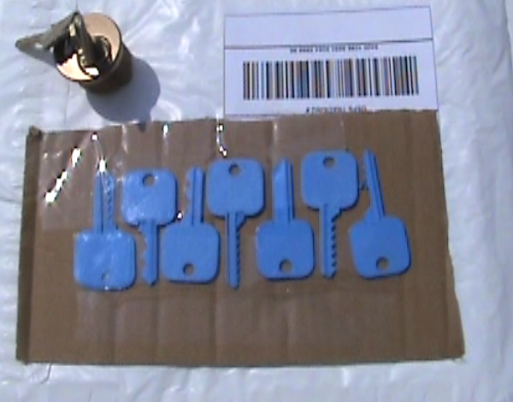

The Schlage code key fits - and works!

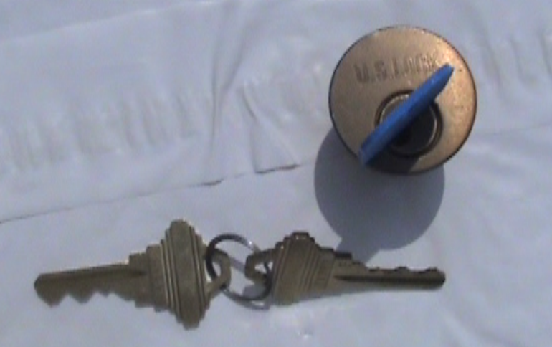

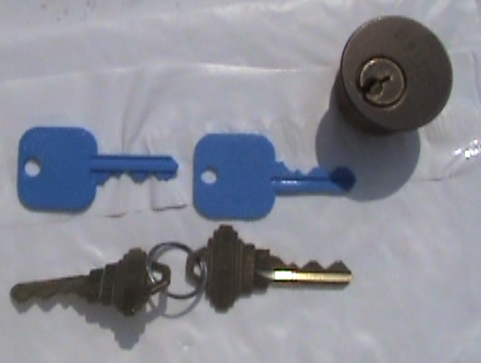

…and the SC4 bump key looks good but needs sanded down a little for a looser fit…

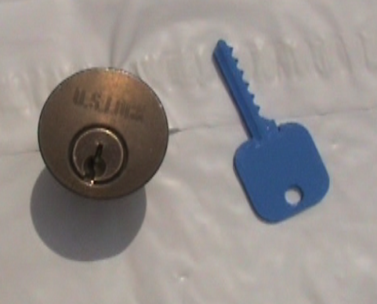

Some fine sandpaper and WD-40 does the trick…

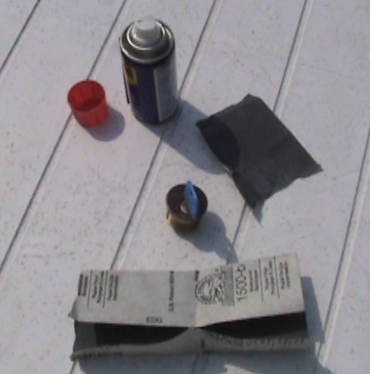

So let’s give it a try…

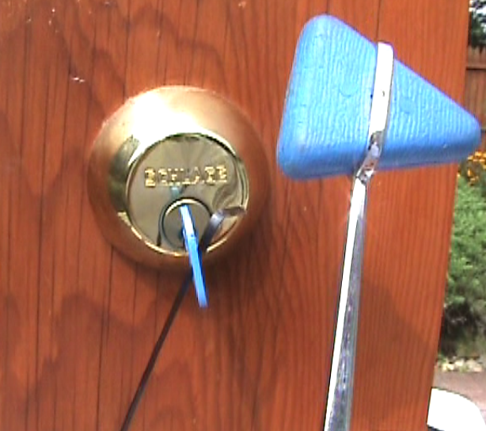

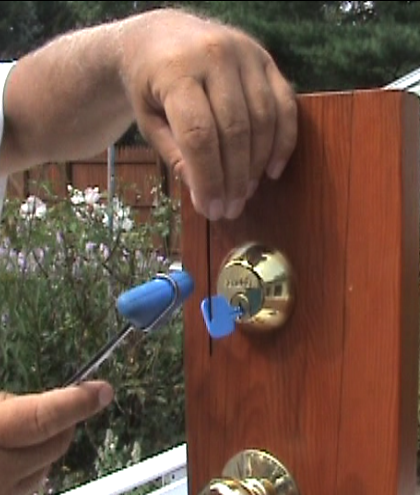

..and it worked…

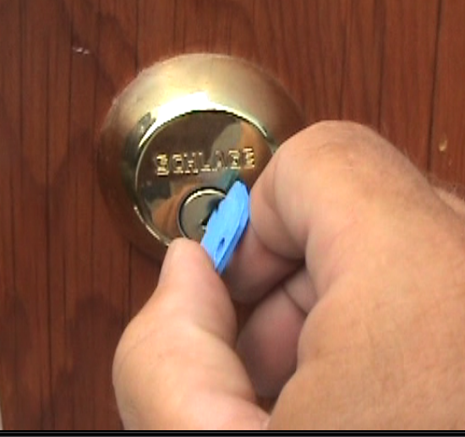

Worked the first time on the first two tries and still looks ok…

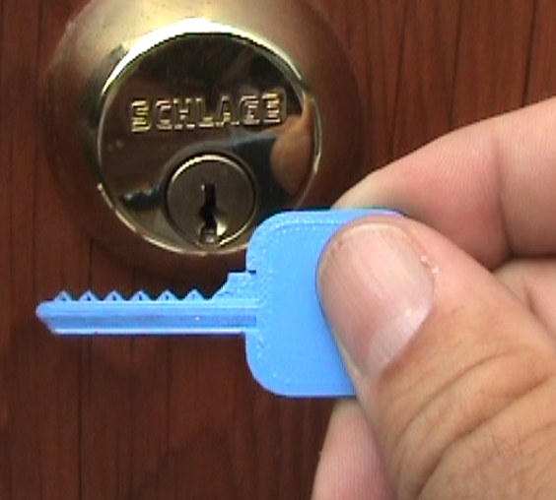

Then it failed! Broke off in the keyway!

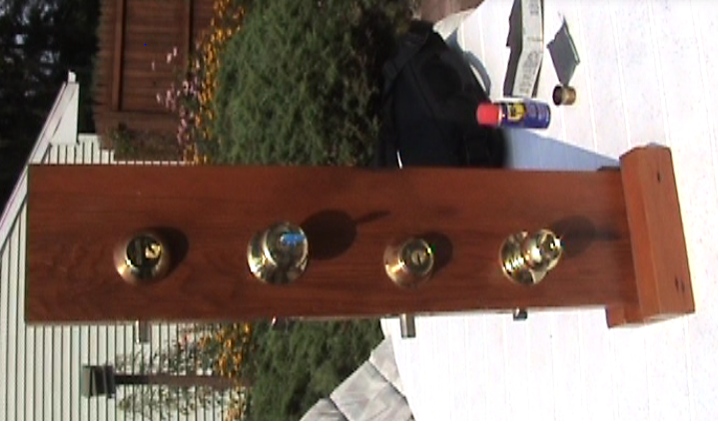

It extracted ok, but PLA is too brittle to use for a bump key!

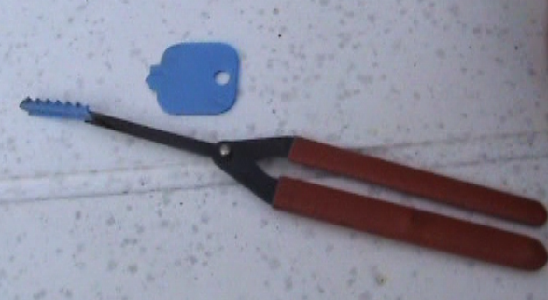

Next test: does it mark well enough for impressioning?

Yes, and with just hand pressure – no vice-grips required.

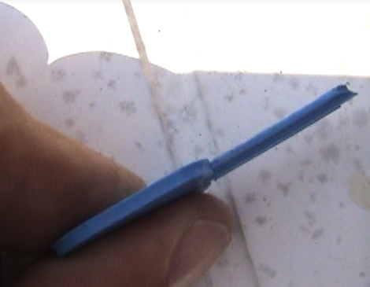

Problem with filing the marks – it shreds the plastic…

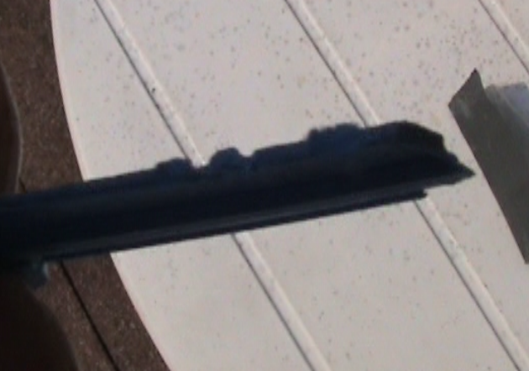

So I tried using a punch to ‘clip’ the blank to the next depth…

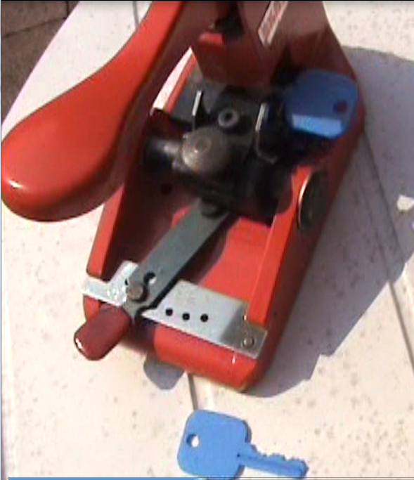

Good results (clipped a 9 cut at the tip of one of the code keys)…

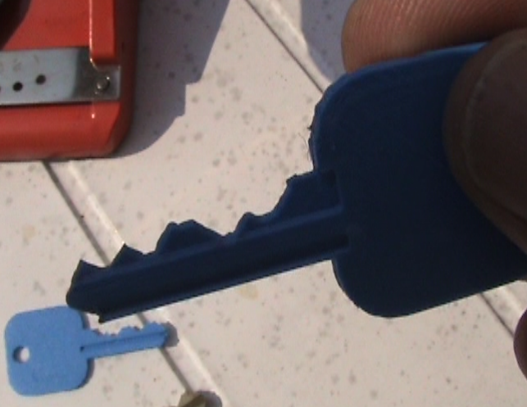

What a fun first day with printed keys!

